**COGNIZANCE**

**TASK-5**

NAME :Moulika

ROLL NO:21232

**TASK-5**

**FIRST FLAG {f1rst_fl@g_h3r3}**

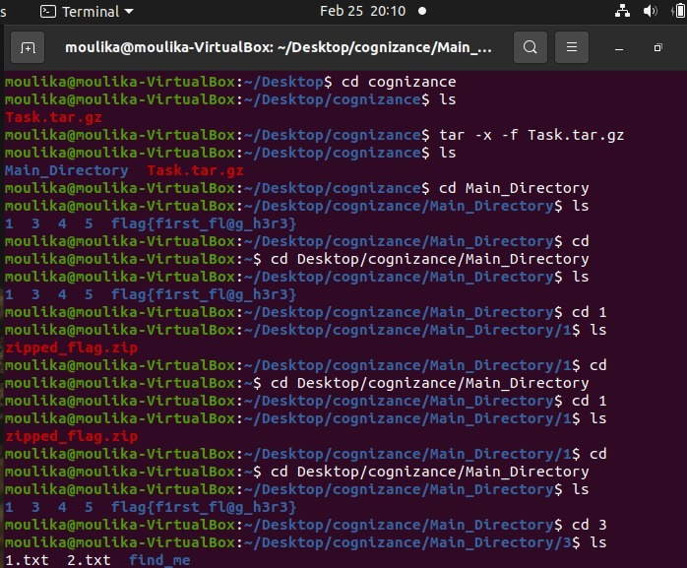

**SECOND FLAG {e@5y_p@ssw0rd!}** 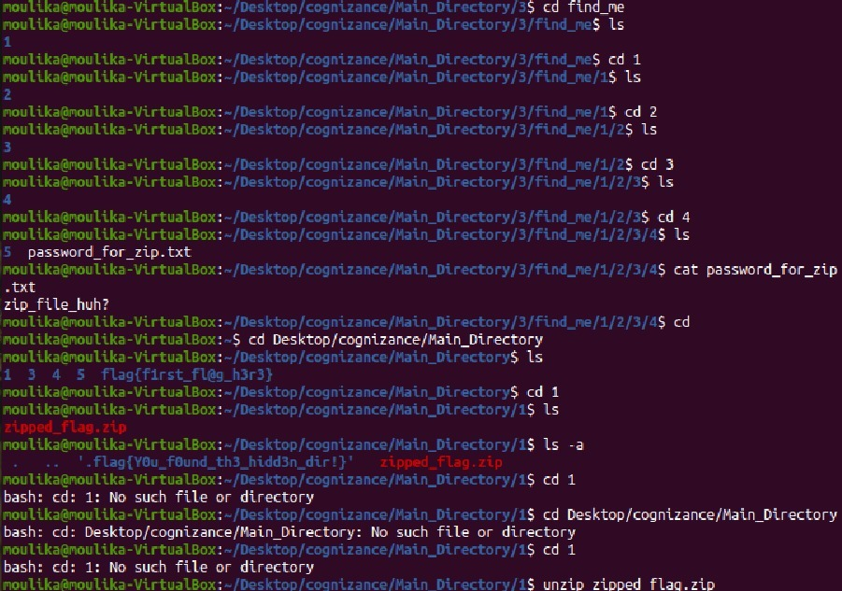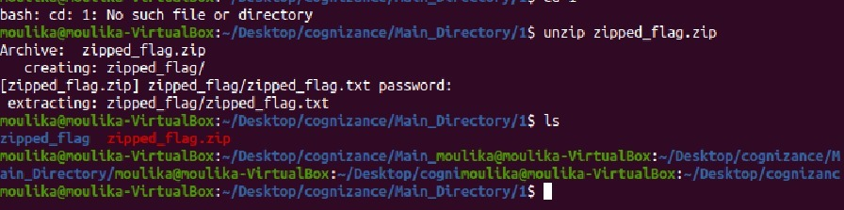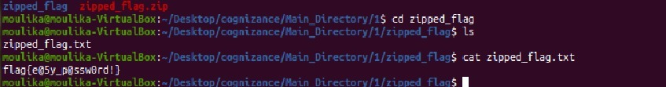

**THIRD FLAG {3x3cut10n_d0n3!}**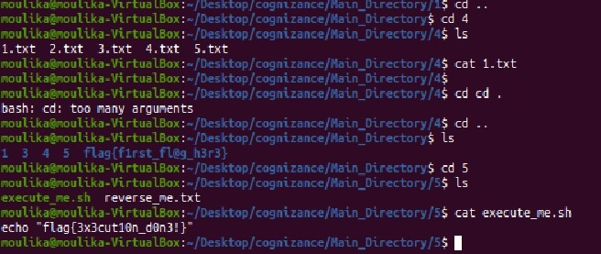

**FOURTH FLAG {t@c | 15 | fun!}**

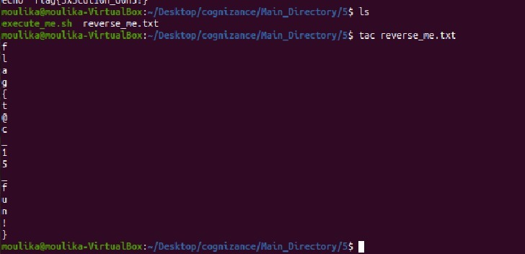

**FIFTH FLAG {m3ow_m3ow_cat!}**   
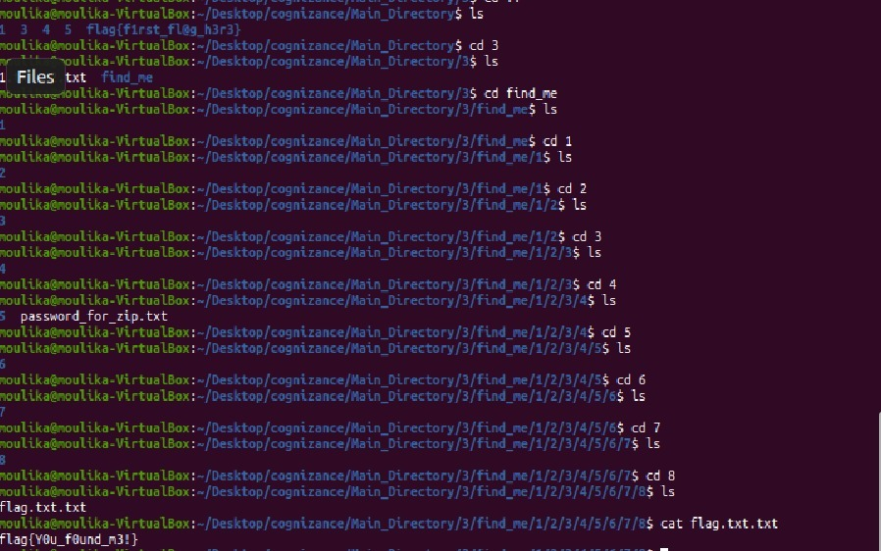

**SIXTH FLAG {gr3p_f1nds_fl@gs!}** 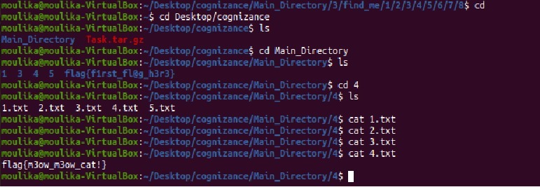

**SEVENTH FLAG{Y0u_f0und_th3_hidd3n_dir!}** 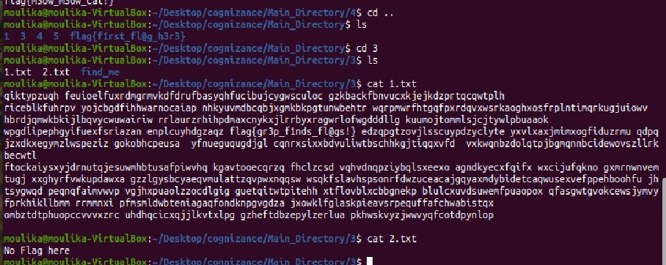

**EIGHTH FLAG{Y0u_f0und_th3_hidd3n_dir!}** 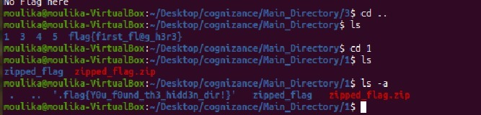

**NINETH FLAG { h1dden_fil3!}** 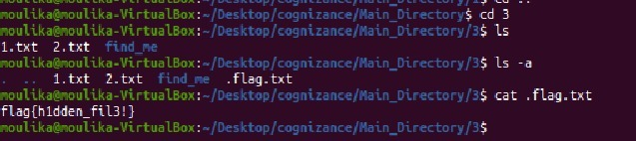

**TENTH FLAG{t3xt_15_n0t_h1dd3n!}** 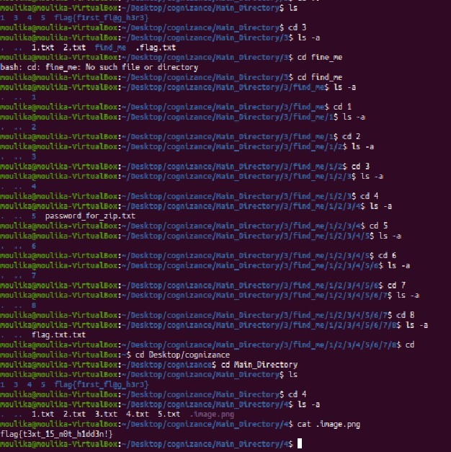

ELEVENTH FLAG{d1ff_15_u53ful!} 